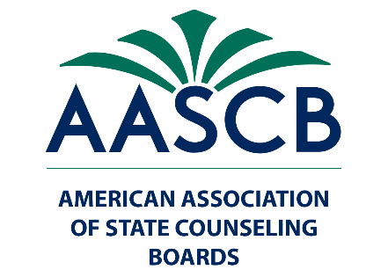

Press Release: Lynn Linde Receives Distinguished Service Award at AASCB Annual Conference
The American Association of State Counseling Boards (AASCB) is proud to announce that Lynn Linde, Chief of Professional Practice at the American Counseling Association, has been honored with the Distinguished Service Award by the American Association of State Counseling Board (AASCB) at the Annual Conference in Tucson, Arizona. The award recognizes Lynn's exceptional contributions and unwavering dedication to the counseling profession.
In remarks at the awards presentation, AASCB President Kim Speakman said:
"This year's Distinguished Service Award recipient is truly remarkable. Through her unwavering dedication and persistent efforts, Lynn has significantly contributed to shaping the future of the counseling profession. She has been a strong advocate for counselors, worked closely with legislators, and has successfully secured crucial funds for the advancement of the profession. Lynn has written numerous articles and conducted countless presentations on our behalf, influencing the trajectory of counseling services nationwide, and has been the face of the Counseling Compact. Without reservation, let us wholeheartedly celebrate Lynn Linde, a truly deserving recipient of this year's Distinguished Service Award."
Lynn Linde's tireless efforts and impactful contributions have not only elevated the counseling profession but have also positively influenced the lives of countless individuals. Her dedication to advocating for counselors and securing essential resources has played a pivotal role in advancing the field of counseling.
AASCB congratulates Lynn Linde on this well-deserved honor and extends its deepest gratitude for her invaluable contributions to the counseling profession.
For media inquiries or further information, please contact Executive Director Matt Grayson at mgrayson@aascb.org
About the American Association of State Counseling Boards: The American Association of State Counseling Boards serves and connects the evolving regulatory community through advocacy and education to promote public protection.
For more information about AASCB, visit www.aascb.org.

